**PRACTICAL 9**

**Aim:Use wcf to Create a basic ASP.NET asynchronous JavaScript and XML (AJAX) service.**

**1.Create a asp.net web application ,name it as myservice.**

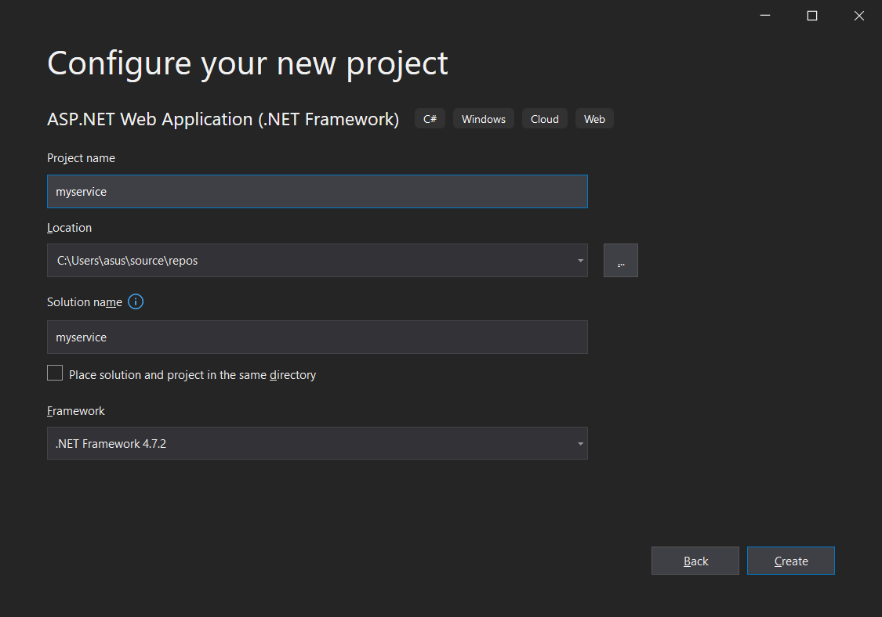

**2.Add a WCF Service (Ajax Enabled)**

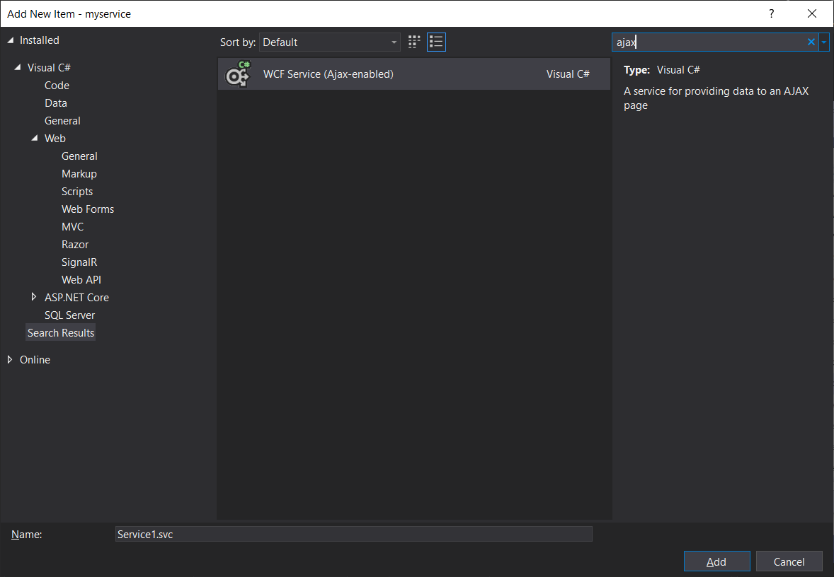

**3) add the code into WCF added file.**

**Code:**

using System;

using System.Collections.Generic;

using System.Linq;

using System.Runtime.Serialization;

using System.ServiceModel;

using System.ServiceModel.Activation;

using System.ServiceModel.Web;

using System.Text;

namespace myajaxservice

{

[ServiceContract(Namespace = "")]

[AspNetCompatibilityRequirements(RequirementsMode = AspNetCompatibilityRequirementsMode.Allowed)]

public class Service1

{

// To use HTTP GET, add [WebGet] attribute. (Default ResponseFormat is WebMessageFormat.Json)

// To create an operation that returns XML,

// add [WebGet(ResponseFormat=WebMessageFormat.Xml)],

// and include the following line in the operation body:

// WebOperationContext.Current.OutgoingResponse.ContentType = "text/xml";

[OperationContract]

public double sum(double a, double b)

{

double result = a + b;

return result;

}

// Add more operations here and mark them with [OperationContract]

}

}

**4.Add a webform keep the name default.**

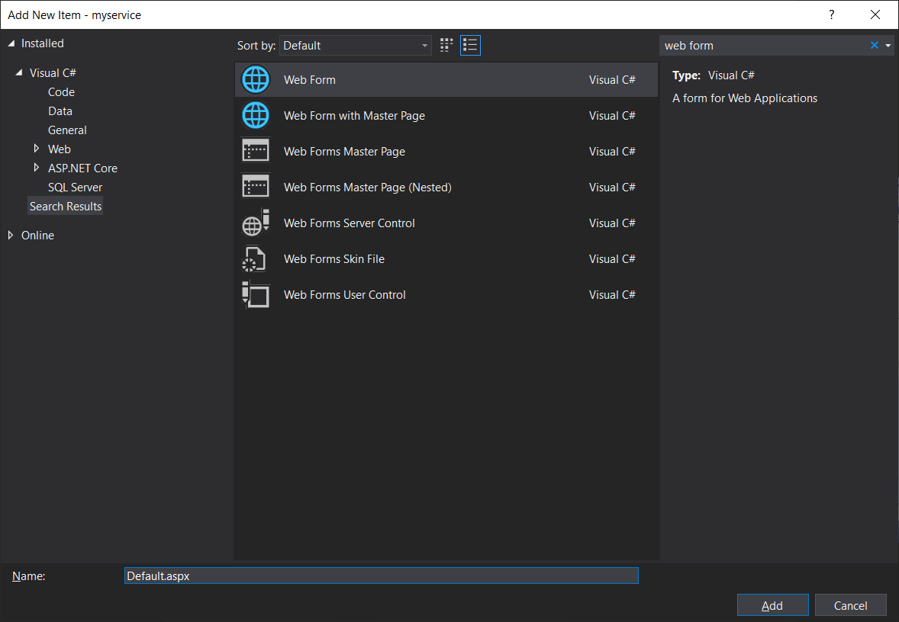

**5) Add the jquery code in default.aspx.**

Default.aspx

<%@ Page Language="C#" AutoEventWireup="true" CodeBehind="Default.aspx.cs" Inherits="myservice.Default" %>

<!DOCTYPE html>

<html xmlns="http://www.w3.org/1999/xhtml">

<head runat="server">

<title></title>

<script type="text/javascript" src="jquery-1.2.js"></script>

<script type="text/javascript" >

$(document).ready(function () {

$("#btn").click(function () {

var num1 = $("#txt1").val(); var num2 = $("#txt2").val();

$.ajax({

url: "MyAJAXService.svc/Sum", type: "POST",

contentType: "application/json; charset=utf-8", data: JSON.stringify({ a: num1,

b: num2 }),

dataType: "json", success: function (data) {

$("#txt3").val(data.d);

}, error: function (err) {

alert(err);

}

});

});

});

</script>

</head>

<body>

<form id="form1" runat="server">

<div style="margin-left: 40px">

&nbsp;<asp:Label ID="Label1" runat="server" Text="Num1"></asp:Label>

&nbsp;

<asp:TextBox ID="txt1" runat="server"></asp:TextBox>

<br />

<br />

<asp:Label ID="Label2" runat="server" Text="Num2"></asp:Label>

&nbsp;

<asp:TextBox ID="txt2" runat="server" OnTextChanged="TextBox2_TextChanged"></asp:TextBox>

<br />

<br />

&nbsp;&nbsp;&nbsp;&nbsp;&nbsp;&nbsp;&nbsp;&nbsp;&nbsp;&nbsp;&nbsp;

<asp:Button ID="txt3" runat="server" OnClick="Button1_Click" Text="Calculate" />

<br />

<br />

&nbsp;&nbsp;&nbsp;&nbsp;&nbsp;&nbsp;&nbsp;&nbsp;&nbsp;&nbsp;&nbsp;&nbsp;&nbsp;&nbsp;&nbsp;

<asp:Label ID="Label3" runat="server"></asp:Label>

</div>

</form>

</body>

</html>

**6) Run the project.**

**Output:**

